Last Updated: 03/18/2020

This guide outlines the steps to request the Other Leave with Pay in SuccessFactors.

Accessing SuccessFactors
Visit OneCampus and select Employee Launchpad.  Log in using Purdue Career Account ID and BoilerKey passphrase. |  | https://one.purdue.edu/  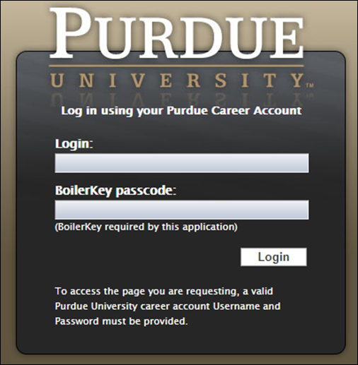
When you have multiple positions follow these directions (or skip to Requesting to Time Off)
If you hold multiple positions, use the Change Selected Employment menu to select the position for which you would like to record time | 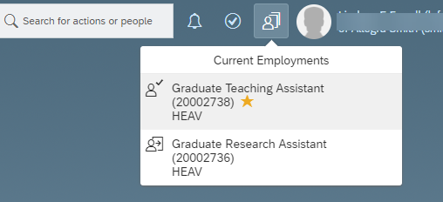
If you hold multiple positions and they are similarly named, click My Profile to validate that the correct position has been selected | 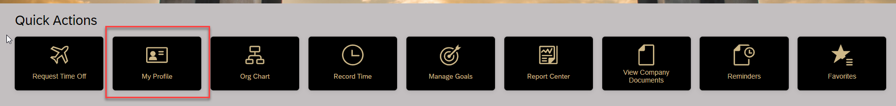
If you hold multiple positions and they are similarly named, click the Employment Information tab to view the details of the position selected in order to ensure time off is requested for the correct position.  Click the Home icon at the top of the page to return to the SuccessFactors home page. | 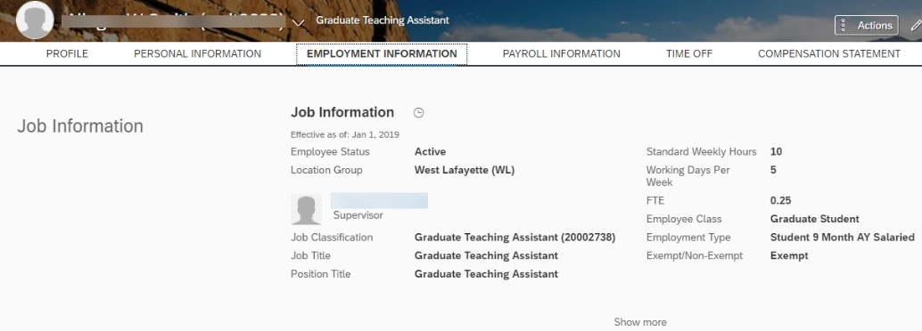  

Requesting Other Leave with Pay
After logging in to SuccessFactors click Request Time Off | 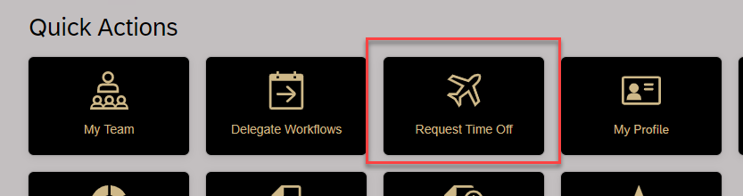
This allows you to Create Absence. You could simply –  - Select Absence type  - Start and End Date  - Click Submit  To view all available balances, view calendars and team absences click Time Off for more detailed absence screens. | 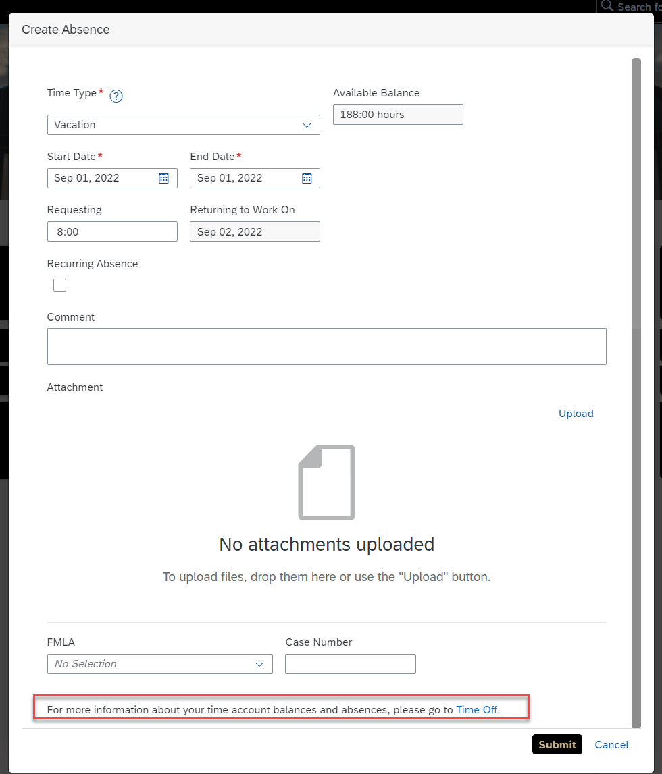
From the Time Off screen, click New Absence.
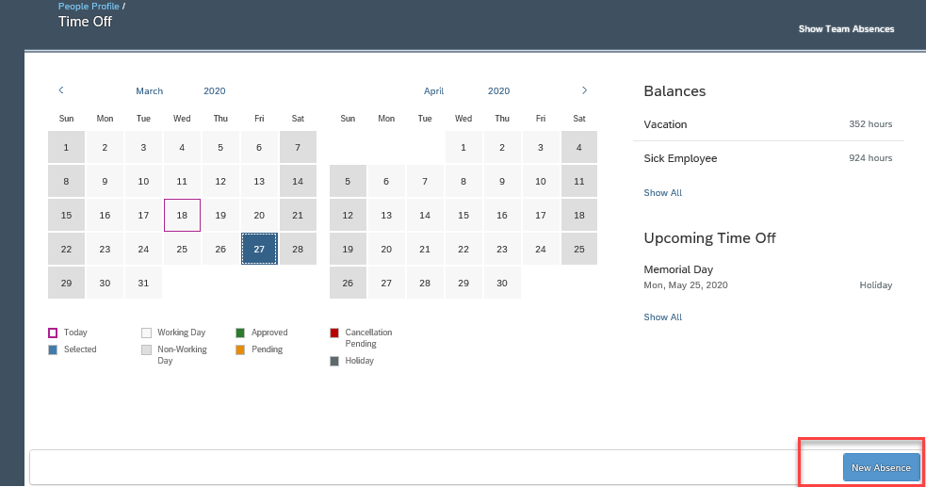
Select Other Leave with Pay from Time Type dropdown list.  - Complete date(s)  - Complete number of hours when not using full day. | 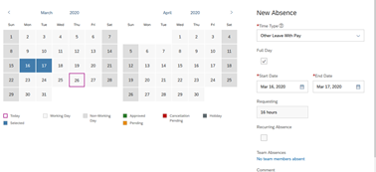
After submitting, the request is listed under the Upcoming Time Off heading with a status of Pending.  The employee’s supervisor receives an email notification that a request has been submitted.  The request is also now indicated as Pending with a gold line on the date on the Calendar.  Once a leave has been approved, the status will change from Pending to Approved. | 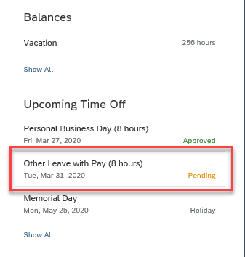

Time Off: Editing or Cancelling
The submitted request can be accessed by clicking the Date on the Calendar, or by clicking the Absence listed under the Upcoming Time Off heading.
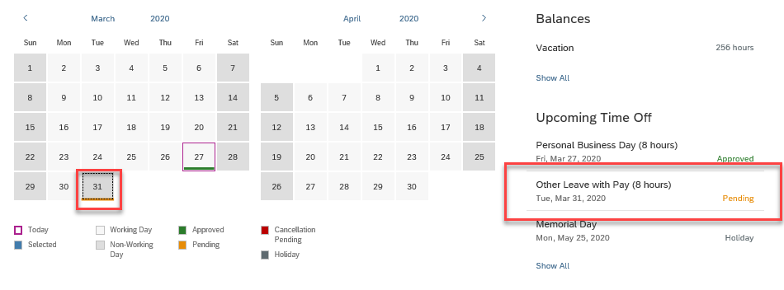
If using the Calendar, click the date and then the Pencil icon to edit. | 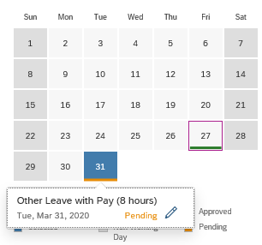
If accessing through Upcoming Time Off, click Edit Absence.  Make necessary edits to the request.  Click Submit.  NOTE: The edited request will be routed for approval only if the original request was already approved. | 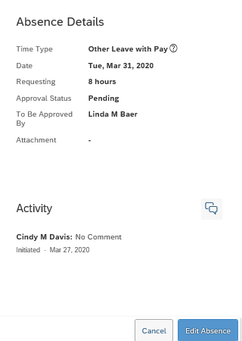
Make necessary edits or cancel the request.  Click Submit after editing or Cancel Absence if deleting or cancelling absence.  NOTE: The edited request will be routed for approval only if the original request was already approved. | 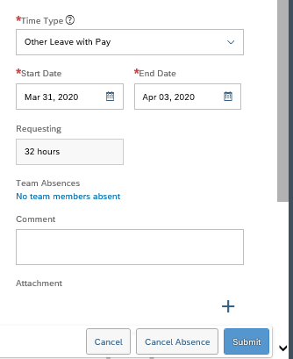
If cancelling, click Yes to confirm cancellation.  Click No to exit from the cancellation request without submitting. | 